I have just installed brackets and the custom region fold extension.
I am on a Mac and have created a project “project_collapse_test”.

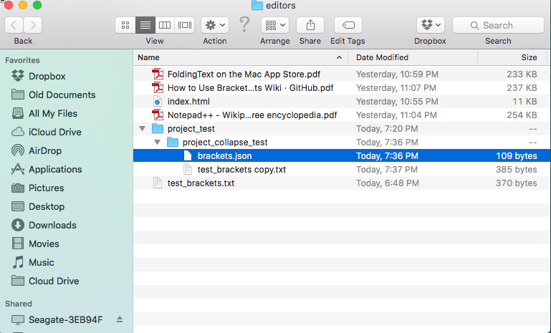

In the project folder there are both “brackets.json” and “.brackets.json” files containing the following:

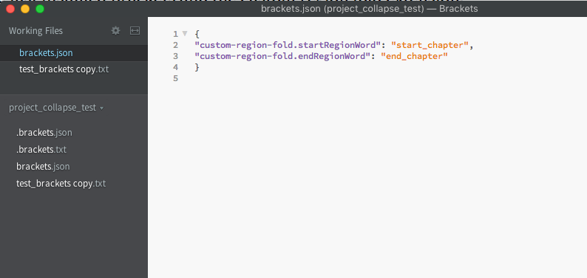

When I edit (with brackets) the following file:

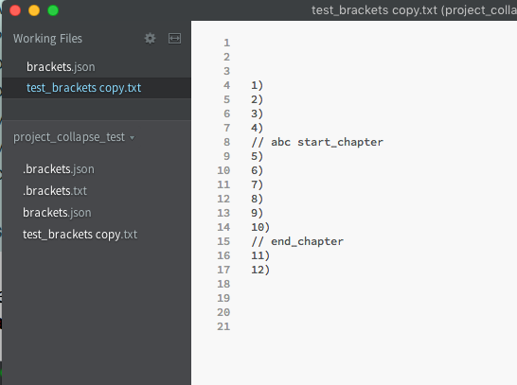

and go to View > Collapse All
nothing happens.

If I select text and View > Collapse Current
it works.

